**CSCI 6461 Fall Semester 2021**

**Project 3 (Team 5)**

**Computer Architecture Simulator**

**Lakshmi Kesava Reddy Indla**

**Indu Goel**

**Humaira Riaz**

**Chengzheng Ye**

**Basic Machine**

**Requirement analysis:**

Build a project to simulate the computer system. As in project 3 we need to design and implement the basic machine. This machine is going to perform several functions. Execute all Instructions. It will also run Program 2.

**Goal:**

Goals of this project are as follows:

Execute All Instructions.

Implement Program 2.

Implement trap instruction.

Implement MFR

**Basic Machine**

The purpose of this project is to:

* Design and implement the basic machine architecture.
* Implement a simple memory
* Execute Load and Store instructions
* Implement the Halt Instruction
* Build simulator front panel
* Execute all instructions
* A program that reads a set of paragraphs of 6 sentences entered by user.
* Enter the search word and it returns the sentence number and the word number.

**Design Notes:**

**Running the JAR File:**

The JAR file can be run in three ways:

1. For Windows double click the downloaded JAR file. You may have to allow access for this to execute  properly.
2. For Mac go to terminal and type.

cd desktop

java -jar CASimulator.jar

1. For Linux, right-click the file, go to “Properties” then “Permissions”, and check the box “Allow executing file as program”.

Please note that the files were compiled with Java 16, so the JAR file may not execute properly if  using an older version of Java.

**GUI (Graphical User Interface):**

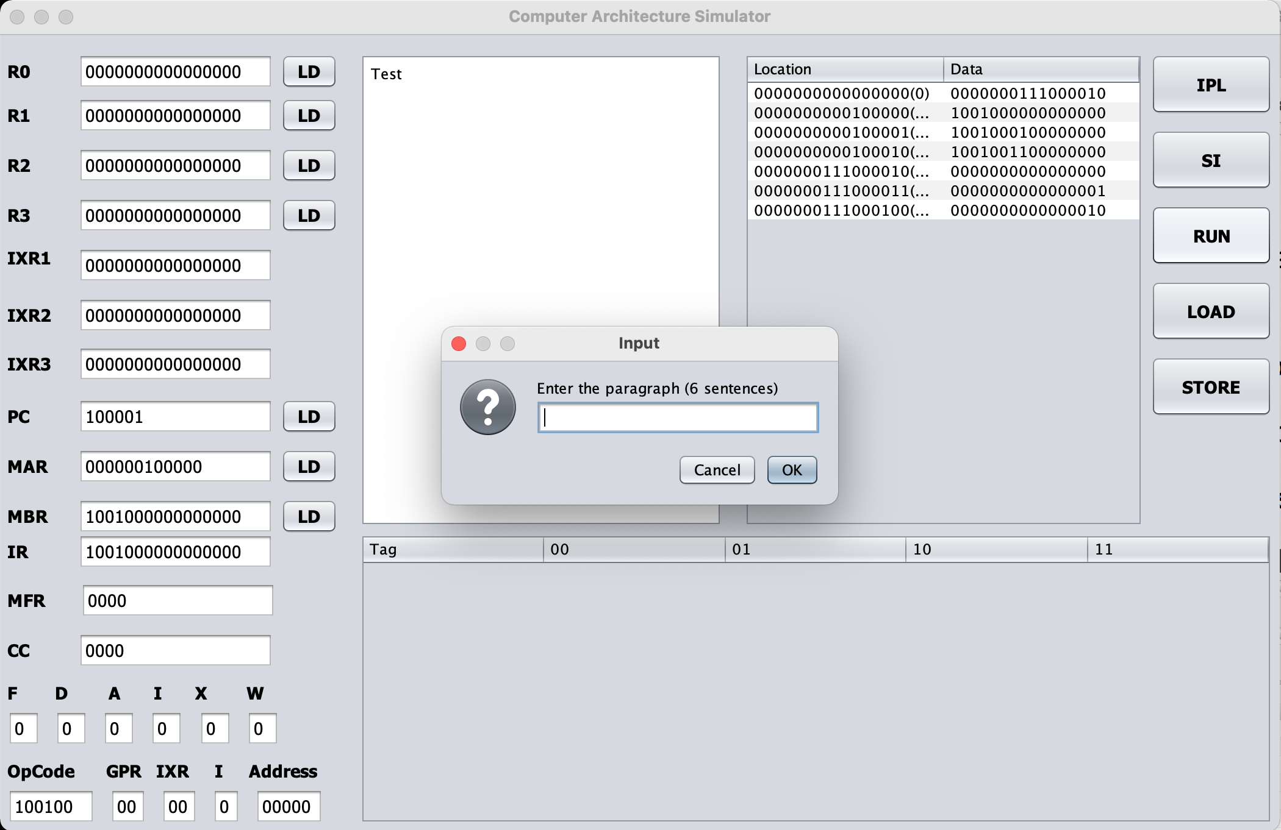

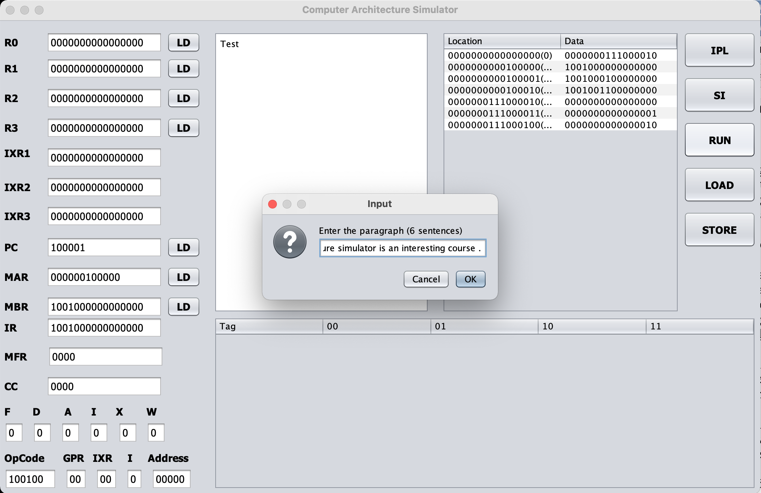

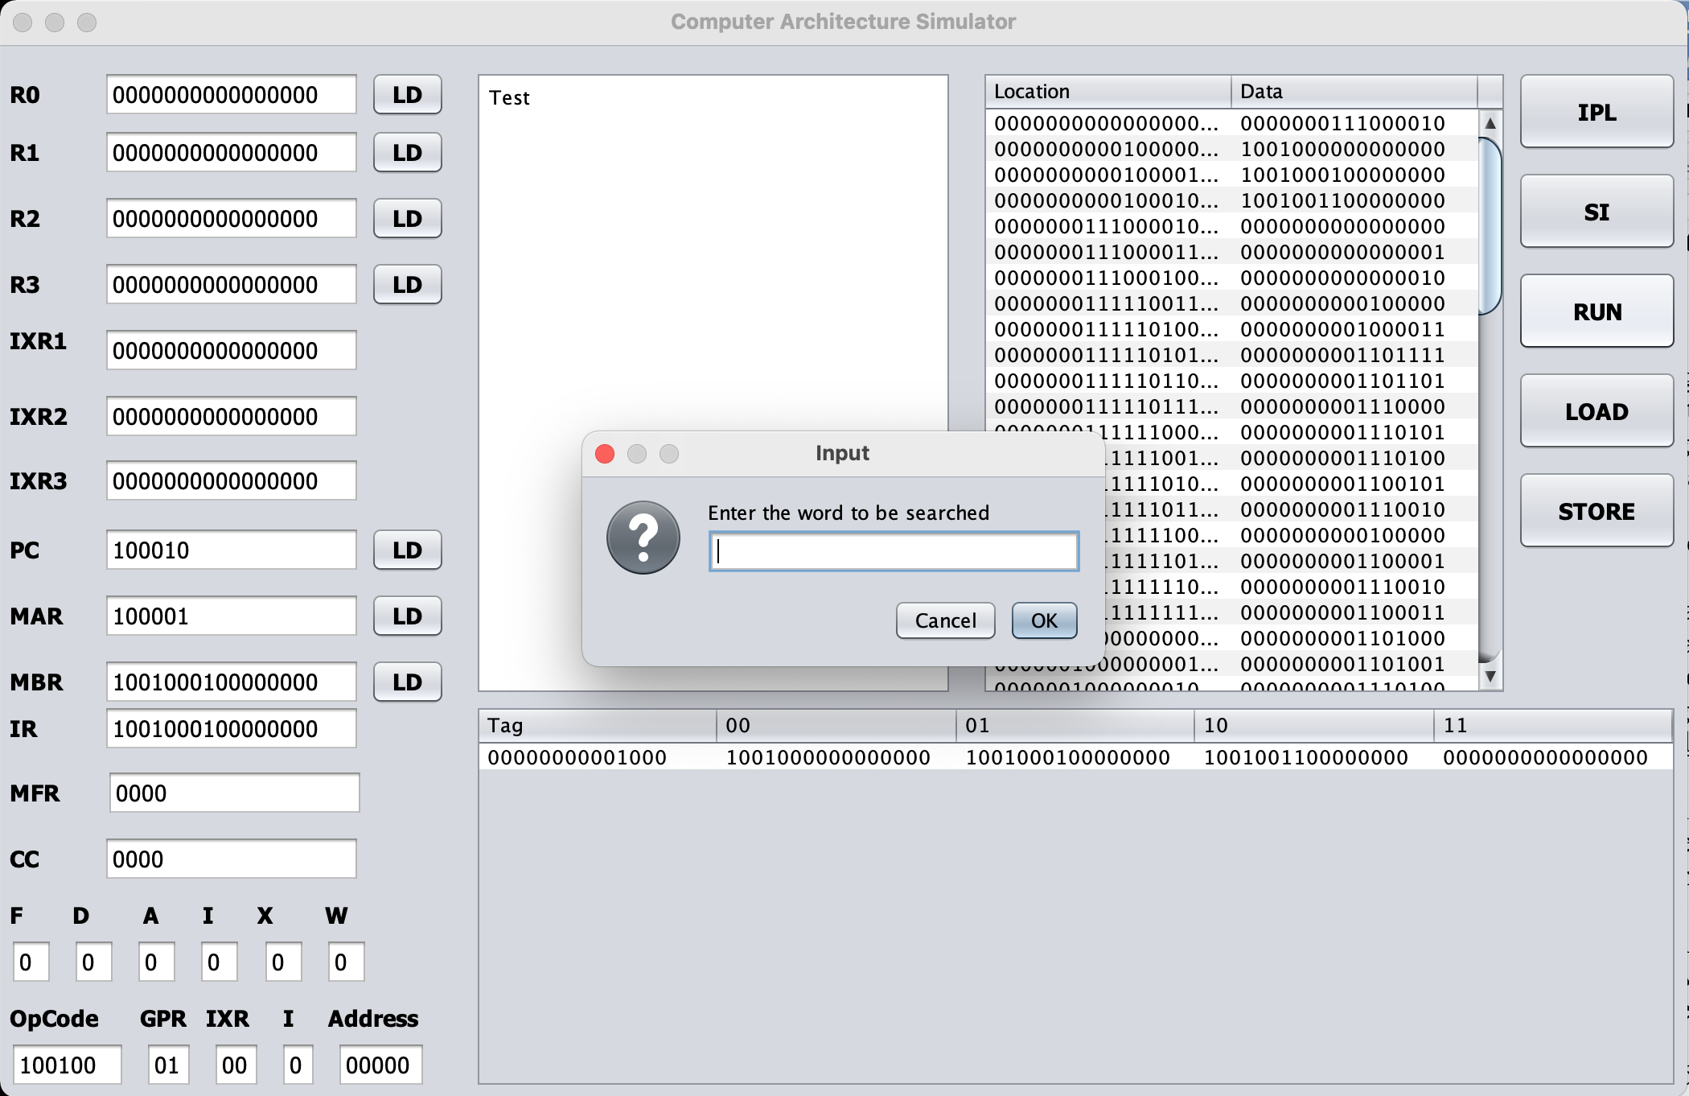

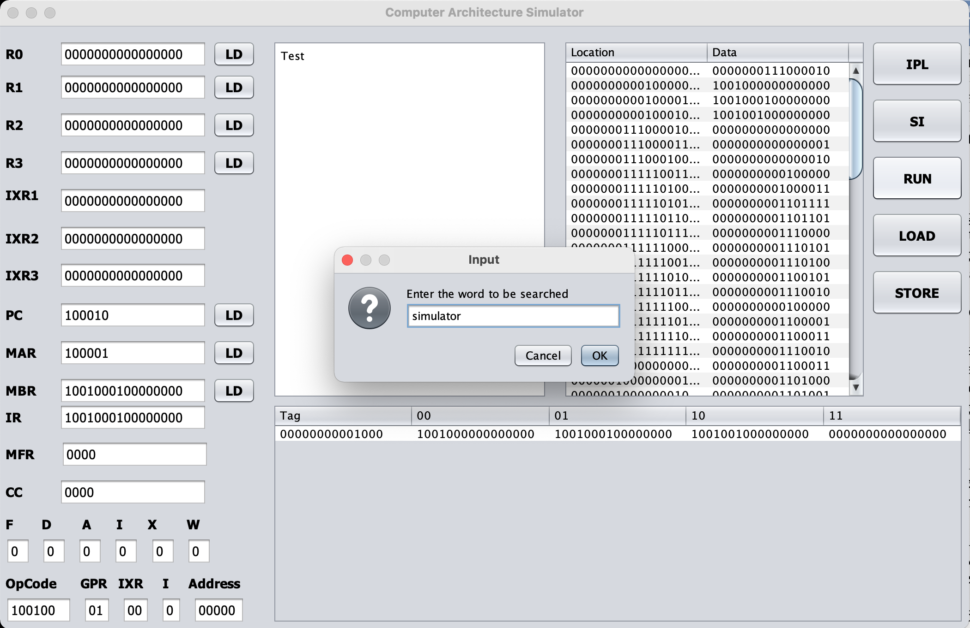

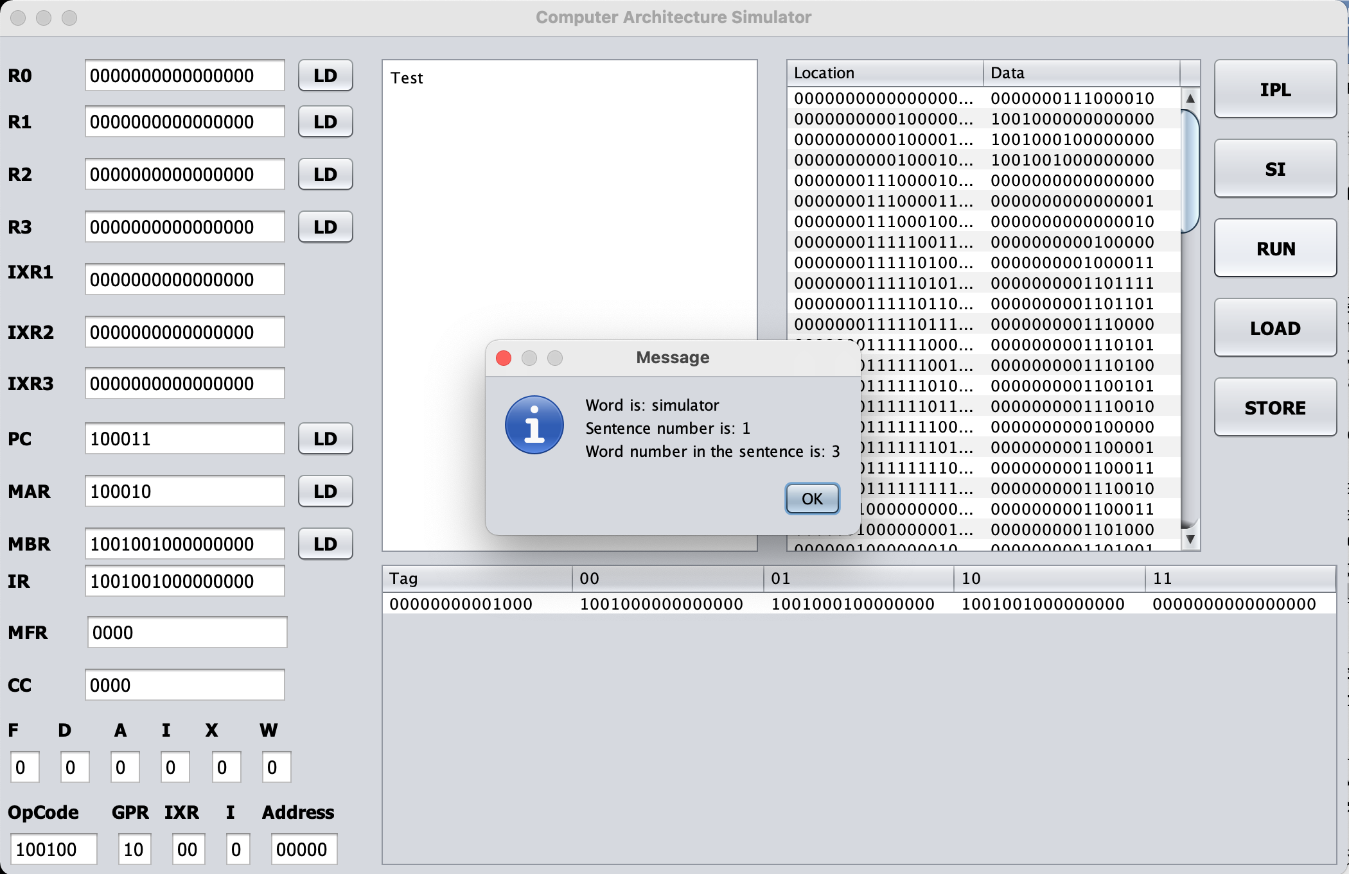

**Basic Buttons and their Functionality:**

1. IPL button loads program into memory .
2. SI button for the single instruction.
3. Run button starts executing instructions in memory
4. Halt button - used to manually halt the machine.(will add it later)
5. Load button will load the instruction.
6. Store is used to manually store a value in the memory.

**How to Operate:**

1. As computer architecture simulator starts you can see that nothing has been uploaded to memory.
2. When you press the IPL button. It will browse for the file. You have to select the ipl.txt file from the location.
3. After selecting the ipl.txt file, the file is loaded and the PC changes to binary value 20.
4. Now click on the run button.
5. A window will pop up. Enter the paragraph of six sentences. Make sure to **put space before period** in every sentence.
6. After entering the sentences click ok.
7. Another window popup asking for the word to that needs to be searched.
8. Click ok then it will return a window showing the word, sentence number and word number.

**Deliverables:**

|  |  |
| --- | --- |
| **Project Requirement** | **What we implement** |
| **Load instruction from file** | Taken care of |
| **Implement Trap instruction** | Used memory location 450 to 465 to store trap instructions. |
| **Implement Program 2** | We implement it by the popup window in which sentences can be entered. The storing of sentence starts from memory location 500.  Word storing starts from memory location 4000. |
| **MFR** | Implemented possible machine faults:  ID Fault  0 MFR set to binary 0001  1 MFR set to binary 0010. 2 MFR set to 0100  3 MFR set to binary 1000 |